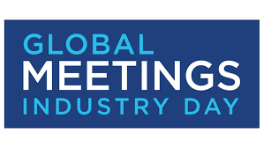

During our GMID Event we will be supporting Covenant House Philadelphia. This organization started 40 years ago supporting the homeless youth. Now they stand as a human rights movement for homeless, as well as trafficked youth in over 31 cities across 6 countries. Please take the time to bring NEW items that are listed below to support the youth of our city:

- twin XL sheets and pillow cases
- towels and wash cloths
- tide pods
- sippy cups/bottles
- newborn diapers
- newborn clothes
- 12-24-month girl clothes
- easy mac and cheese
- notebooks
- 3 ring binders
- book bags
- umbrellas
- ponchos
- gift cards (Visa, Target and Walmart)

