Speaker Bios for the

February 2, 2023 PCMA PHL Breakfast Meeting:
Building Accessibility Into Events:

What Are You Responsible For? What Should You Be Doing?

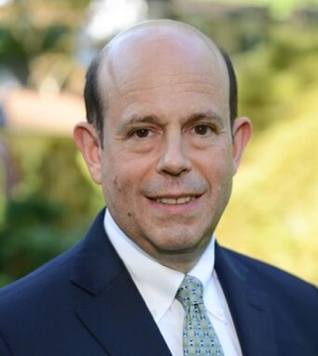
Joshua L. Grimes, Esq.
GRIMES LAW OFFICES, LLC

Joshua L. Grimes, Esq., of Grimes Law Offices based in Philadelphia, is a leading attorney in the association, nonprofit, meeting, and hospitality industries. He is a specialist in all matters relating meetings and conventions, as well as association & nonprofit governance.
Mr. Grimes’ expertise includes preparing and negotiating all types of meeting and event contracts. He also advises clients on avoiding liability risks. Many organizations also rely on Mr. Grimes to aggressively represent their interests when disputes arise, including in litigation, mediation, and other resolution procedures.
During the COVID-19 crisis, Mr. Grimes advised meeting planners and event hosts on legal strategies for meeting cancellations, rescheduling, and virtual meetings. He is now advising clients on the best ways to adapt their meetings and policies in the face of continued medical and economic uncertainty. This includes identifying new contract provisions that change customary meeting terms, and ensuring that provisions are fair for all parties and promote successful events.
Mr. Grimes is a member of the APEX Contracts Panel, and he served on the Board of Directors of the Academy of Hospitality Industry Attorneys. He was awarded the 2019 Partnership Award by the PCMA Greater Philadelphia Chapter, and was named a Meetings Trendsetter by Meetings Today publication.
Mr. Grimes is one of the association and meeting industries’ most prominent speakers. He has appeared before industry professionals throughout the United States, and in Europe, the Middle East, Canada, and Mexico. Aside from his legal practice, Mr. Grimes proudly serves as an elected official, as a Commissioner in Lower Merion Township, Pennsylvania.

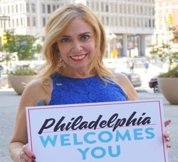
SHEILA HESS BIOGRAPHY | Philadelphia City Representative -
@SheilaShowPHL and @PhillyCityRep. Contact: Sheila.hess@phila.gov | 215.868.3171

In 2016, Mayor Jim Kenney appointed Sheila Hess to the position of Philadelphia’s City Representative. Her office serves as the premier PR, marketing and promotional department of the City of Philadelphia, producing ceremonial and special events while celebrating Philadelphia’s diversity through citywide event creation, community engagement and innovative experiences.

Her foray into civic service in her beloved city is a dream come true. She relishes the opportunity to “tell the City’s positive story,” connecting the perfect union of projects and people. With pride, passion and purpose, Sheila, currently serves on a variety of non-profit tourism and hospitality boards and committees that promote Philadelphia locally and nationally, and others that serve the disabled, disadvantaged and underserved: Global Philadelphia, Philadelphia Convention & Visitors Bureau (PHLCVB), Visit Philadelphia, Philadelphia250, Philadelphia Soccer 2026 Social Impact Council for the 2026 World Cup Host City, Historic Philadelphia, Inc., Greater Philadelphia Film Office, Police Athletic League (PAL), Fred’s Footsteps and is actively involved with Welcome America, Inc. partnering on July 4th Celebration of Freedom Ceremony and City Hall Tree Lighting Celebration, produced by the Office of City Representative. She is an alum and past board member of LEADERSHIP Philadelphia.

She is a difference maker, and has earned a reputation as a stellar coalition builder and compassionate, energetic advocate who is always building and promoting the image of Philadelphia. She has been called Philadelphia’s “top cheerleader.”

Sheila joined the city after an accomplished 24-year career at Independence Blue Cross (IBC), where she proudly served as Director IBC Foundation & Community Affairs and creator of the award-winning Blue Crew corporate volunteer program.

In 2022, Hess was identified by City & State PA Magazine as one of the Pennsylvania Power of Diversity: Women 100 most influential female leaders. She was recognized as one of the 50 Philly Power Women in 2021 by Metro Philadelphia for empowerment, leadership and sisterhood, working every day to make Philadelphia a better place. Sheila’s personal story was highlighted on 6ABC by reporter Tahronda Thomas in July 2022 during Disability Pride Month titled: Philadelphia's top representative takes pride in her disability, and onCBS3 Philly in February 2020 with reporter Jessica Kartalija for a special feature called “A Chat With” City Representative. In 2020, she served as a judge for the inaugural AL DÍA 40 Under 40. She was selected as an honoree for the 2020 St. Patrick’s Ring of Honor during the 250th annual Philadelphia St. Patrick’s Day Parade. She is the recipient of the 2019 Sally Berlin PR SPOTLIGHT Award from the Police Athletic League and the 2018 Ambassador Award from Variety-The Children’s Charity, that provides assistance to children and youth with physical and developmental disabilities. In 2017, she received a Special Recognition Award from the Legal Clinic for the Disabled, named a Women of the Year Honoree “Unmasking the Legacy” Award from PhillyMan/JerseyMan Magazine, and in 2016 Philadelphia Pinnacle Award from her alma mater, St. Maria Goretti H.S. in South Philly. She was recognized as one of the Philadelphia Business Journal’s “40 Under 40” in 2007 and earned the distinction as one of the city’s “Top 101 Emerging Connectors” by LEADERSHIP Philadelphia.

She is a proud Temple University graduate and recipient of the Diamond Excellence Award presented by Temple University Young Alumni in 2010. In 2022, she served as a judge for AL DÍA Women of Merit.

In 2021, Sheila was host of two different Ready, Set, Philly! Good News RoundUp segments.
In 2021 and 2020, she served as co-host for The Globy Awards. In 2022, she hosted a Phillies pep rally for the City. In 2021, was emcee for the Philly Holiday Experience press conference. In 2016, she garnered national attention from ESPN Radio, WDAS Radio’s Women To Watch program and was identified as one of five Philadelphia women moving the needle in the City of Brotherly Love by Philadelphia Style magazine. She was recently identified as a “Remarkable Women” and featured on Marilyn Russell’s 98.1 WOGL radio show and did a monthly radio segment on Classix 107.9 with Dyana Williams discussing free fun events in Philadelphia.

Sheila was born with a disability, Spina Bifida, and is a lifelong resident of South Philadelphia, where she currently resides with her husband Michael.

You can follow Sheila Hess on social media: Instagram, Twitter, LinkedIn: @SheilaShowPHL @PhillyCityRep.

Lakshmee Lachhman-Persad - Founder
AccessibleTravelNYC@gmail.com |917-392-7264
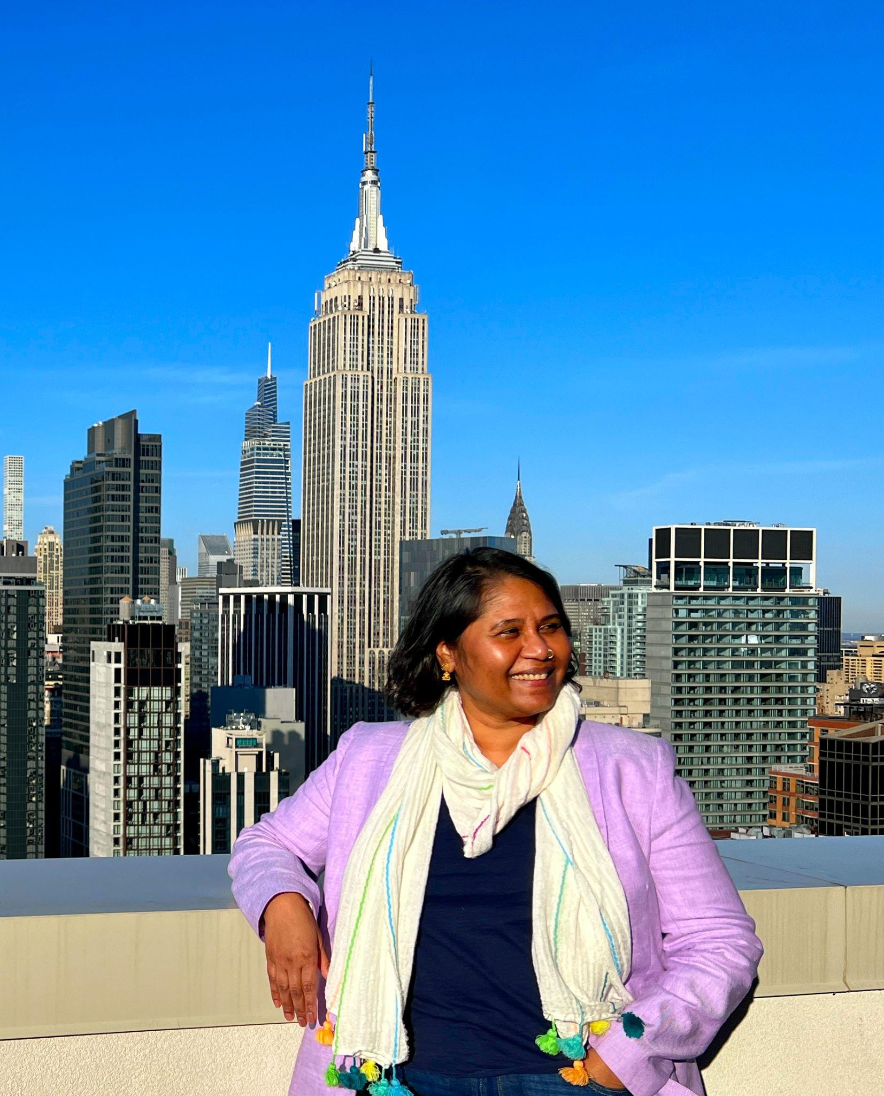
Lakshmee Lachhman-Persad (she/her), a marketer and educator with 25 years of experience in the travel and tourism industry, is an influential change maker with a powerful focus on positive disability representation of and marketing to people with disabilities and disability inclusion. When she recognized the total absence of marketing intended to attract disabled visitors to New York City, she created www.AccessibleTravelNYC.com. Her goal: to inspire and empower people with disabilities and their families and friends to plan and enjoy their New York City travel. Media images of her family and their story were the first (historic!) to represent disability inclusion by NYC & Company, the city’s official destination marketing organization.
Lakshmee has since worked with major attractions such as The New York Botanical Garden, the Metropolitan Museum of Art, the Statue of Liberty, Lincoln Center, MTA Away and her story has been highlighted on CBS News, The Drew Barrymore Show, and CherryBombe, a indie media company celebrating women in the food industry. She co-educates major organizations and attractions such as NYC & Company, Visit Boston, Summit One Vanderbilt, One World Observatory, Arlo Hotels, Jacob Javist Center and more on how to weave disability inclusion and accessibility throughout their platforms and programs as part of their Diversity, Equity, Inclusion and Accessibility (DEIA) mission.
She serves on the Board of Directors of NYC & Company and is Co-Chair of the DEIA Committee; she served on the Coalition for NYC Hospitality & Tourism Recovery for NYC & Company; she is a member of the Advisory Committee for Transit Accessibility (ACTA) at the Metropolitan Transportation Authority (MTA); and she is the leader on DEIA on the board of directors of the New York Chapter of Professional Convention Management Association (PCMA). She was awarded the prestigious Sapolin Public Accommodations Award from Mayor Adams for her unwavering community advocacy during the celebration of the ADA 32 July 2022. She was recently awarded the 2022 Adapt Award for her contributions to NYPCMA chapter and community and is a finalist for the Advocate of the Year at PCMA’s Visionary Award in March 2023.
Lakshmee uses her many service roles to help support and uplift the marginalized communities she is proud to be a part of, including people with disabilities, people of color, low-income communities, the Bronx and New York’s immigrant Caribbean community. Her work is anchored in Disability Pride and intentional Disability Joy.
Lakshmee, an immigrant from Guyana, lives in the Bronx with her husband and two teenage children. She supports her mother to care for her sister Annie, a wheelchair user with cerebral palsy. It is this close and devoted family relationship along with her own disabilities that led her into advocacy for people with disabilities and for accessibility for all within the travel and tourism industry.

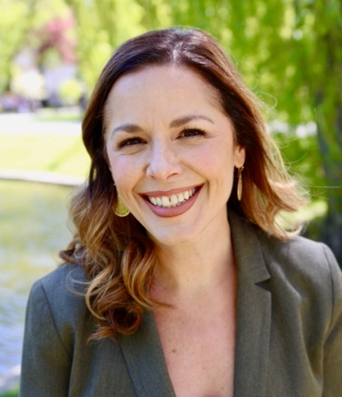

Mariellen Morris, MA, is the Senior Director of Conferences and Membership at Public Responsibility in Medicine and Research (PRIM&R), a nonprofit organization in Boston, MA. In this role, Ms. Morris oversees the operation, strategy, budget, and planning of both PRIM&R’s membership department and its Annual Conference. Ms. Morris is an experienced events professional with a demonstrated history (10+ years) of planning successful association events from 10 to 3000 people, and in person, virtual, and hybrid formats. In addition to her work at PRIM&R, Ms. Morris is an active member of the Professional Convention Management Association (PCMA), where she serves as board member and Education Committee member for the Greater Philadelphia Chapter; is a member of the Anaheim Customer Advisory Board; and has presented on meeting-related topics for educational events. Ms. Morris graduated from Westfield State University in 2003 with a BA in communications and Spanish, and she received a MA in organizational communication from Suffolk University in 2006.

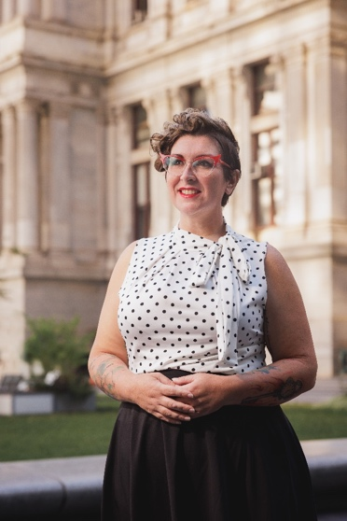

Amy Nieves (she/her) — Executive Director, for the Mayor’s Office for People with Disabilities which oversees the Mayor’s Commission on People with Disabilities, the Office of ADA Compliance and Constituent Services. Together these offices work to make Philadelphia a better place for people with disabilities. As a neurodivergent with deafness, and as a person in addiction recovery, Amy has built her career as a statewide and nationally recognized advocate on the forefront of supporting families as a facilitator, keynote speaker, published author, and community leader. Additionally, Amy is a Governor-appointed Council member of PADDC and PASILC. She completed her undergraduate degree at York College of PA in 2002 and obtained her Masters in Human Relations: Diversity, Equity, and Social Justice at the University of Oklahoma in 2022. Amy has long advocated that equity, opportunity, and inclusion are rights for all people. She shared her own recovery story with the City of Philadelphia on the Department’s DEI Blog Post.

